**Creating Microservices for account and loan**

In this hands on exercises, we will create two microservices for a bank. One microservice for handing accounts and one for handling loans.

Each microservice will be a specific independent Spring RESTful Webservice maven project having it's own pom.xml. The only difference is that, instead of having both account and loan as a single application, it is split into two different applications. These webservices will be a simple service without any backend connectivity.

Follow steps below to implement the two microservices:

**Account Microservice**

* Create folder with employee id in D: drive
* Create folder named 'microservices' in the new folder created in previous step. This folder will contain all the sample projects that we will create for learning microservices.
* Open https://start.spring.io/ in browser
* Enter form field values as specified below: o Group: com.cognizant o Artifact: account
* Select the following modules o Developer Tools > Spring Boot DevTools o Web > Spring Web • Click generate and download the zip file
* Extract 'account' folder from the zip and place this folder in the 'microservices' folder created earlier
* Open command prompt in account folder and build using mvn clean package command
* Import this project in Eclipse and implement a controller method for getting account details based on account number. Refer specification below:

1. Method: GET
2. Endpoint: /accounts/{number}
3. Sample Response. Just a dummy response without any backend connectivity.

{ number: "00987987973432", type: "savings", balance: 234343 }

* Launch by running the application class and test the service in browser.

**Solution**

**AccountController.java**

package com.cognizant.account;

import org.springframework.web.bind.annotation.GetMapping;

import org.springframework.web.bind.annotation.PathVariable;

import org.springframework.web.bind.annotation.RestController;

import java.util.Map;

@RestController

public class AccountController {

@GetMapping("/accounts/{number}")

public Map<String, Object> getAccountDetails(@PathVariable String number) {

return Map.of(

"A/C Number", number,

"Type", "Fixed Deposit",

"Balance", 10234343

);

}

}

**Output**

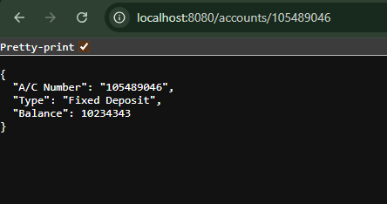

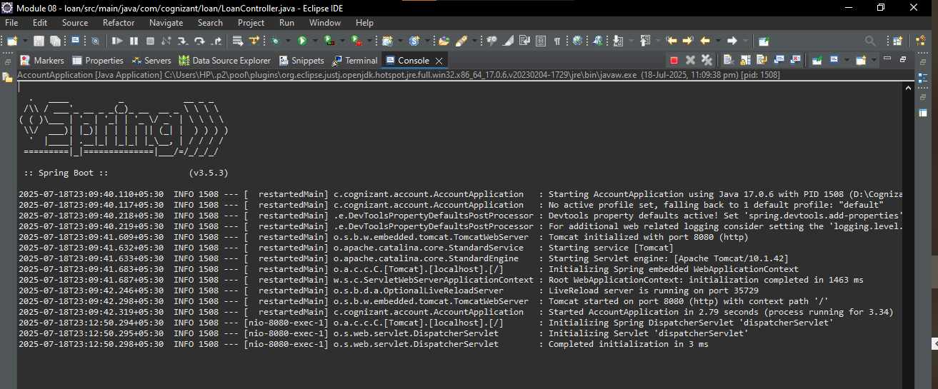

**Loan Microservice**

* Follow similar steps specified for Account Microservice and implement a service API to get loan account details

1. Method: GET
2. Endpoint: /loans/{number}
3. Sample Response. Just a dummy response without any backend connectivity.

{ number: "H00987987972342", type: "car", loan: 400000, emi: 3258, tenure: 18 }

* Launching this application by having account service already running
* This launch will fail with error that the bind address is already in use
* The reason is that each one of the service is launched with default port number as 8080. Account service is already using this port and it is not available for loan service.
* Include "server.port" property with value 8081 and try launching the application
* Test the service with 8081 port

Now we have two microservices running on different ports.

NOTE: The console window of Eclipse will have both the service console running. To switch between different consoles use the monitor icon within the console view.

**Solution**

**LoanController.java**

package com.cognizant.loan;

import org.springframework.web.bind.annotation.GetMapping;

import org.springframework.web.bind.annotation.PathVariable;

import org.springframework.web.bind.annotation.RestController;

import java.util.Map;

@RestController

public class LoanController {

@GetMapping("/loans/{number}")

public Map<String, Object> getLoanDetails(@PathVariable String number) {

return Map.of(

"Loan Number", number,

"Type", "House",

"Loan Amount", 4000000,

"EMI", 11450,

"Tenure", 30

);

}

}

**Output**

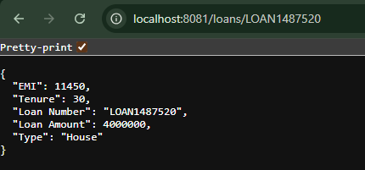

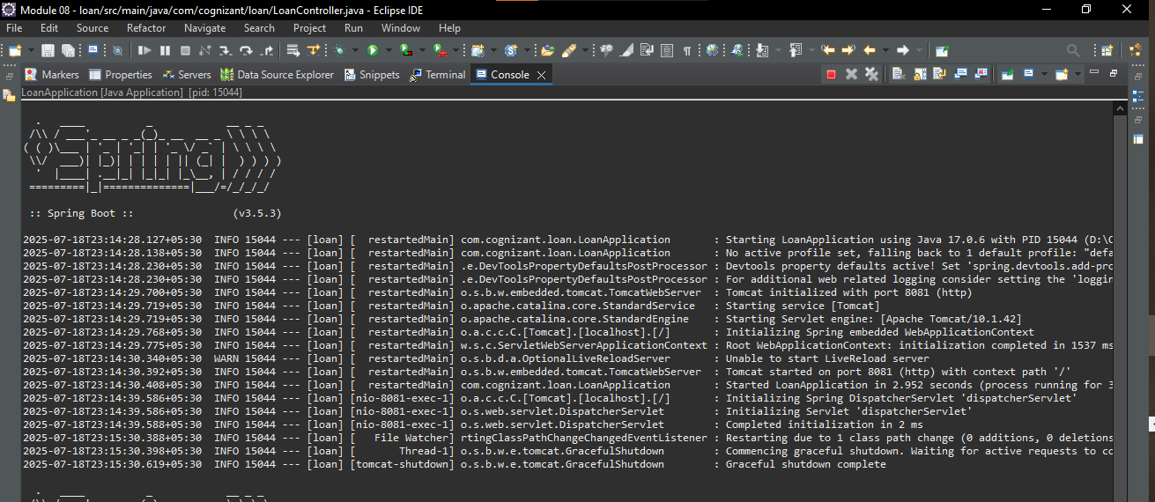

**Create Eureka Discovery Server and register microservices**

Eureka Discovery Server holds a registry of all the services that are available for immediate consumption. Anybody whom wants to consume a RESTful Web Service can come to the discovery server and find out what is available and ready for consumption. Eureka Discovery Server is part of spring cloud module.

Follow steps below to implement:

**Create and Launch Eureka Discovery Server**

* Using https://start.spring.io generate a project with following configuration:
* Group: com.cognizant
* Artifact: eureka-discovery-server
* Module: Spring Cloud Discovery > Eureka Server
* Download the project, build it using maven in command line
* Import the project in Eclipse
* Include @EnableEurekaServer in class EurekaDiscoveryServerApplication
* Include the following configurations in application.properties: server.port=8761 eureka.client.register-with-eureka=false eureka.client.fetch-registry=false logging.level.com.netflix.eureka=OFF logging.level.com.netflix.discovery=OFF
* The above configuration runs the discovery service in port 8761
* The eureka properties prohibits direct registration of services, instead discovery server will find available services and register them.
* Launch the service by running the application class
* The discovery service can be view by launching http://locahost:8761 in the browser.
* This will display the discover server details
* Look into the section "Instances currently registered with Eureka", which will have an empty list
* Follow steps below to add account and loan service to this discovery server.

**Solution**

**application.properties**

server.port=8761

eureka.client.register-with-eureka=false

eureka.client.fetch-registry=false

logging.level.com.netflix.eureka=OFF

logging.level.com.netflix.discovery=OFF

**EurekaDiscoveryServerApplication.java**

package com.cognizant.eureka_discovery_server;

import org.springframework.boot.SpringApplication;

import org.springframework.boot.autoconfigure.SpringBootApplication;

import org.springframework.cloud.netflix.eureka.server.EnableEurekaServer;

@SpringBootApplication

@EnableEurekaServer

public class EurekaDiscoveryServerApplication {

public static void main(String[] args) {

SpringApplication.run(EurekaDiscoveryServerApplication.class, args);

}

}

**Output**

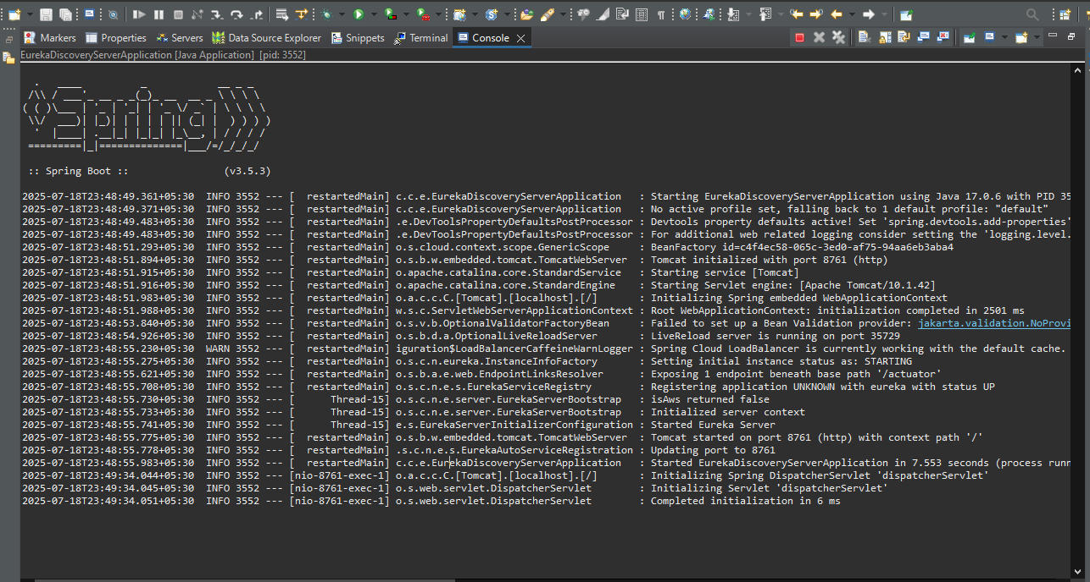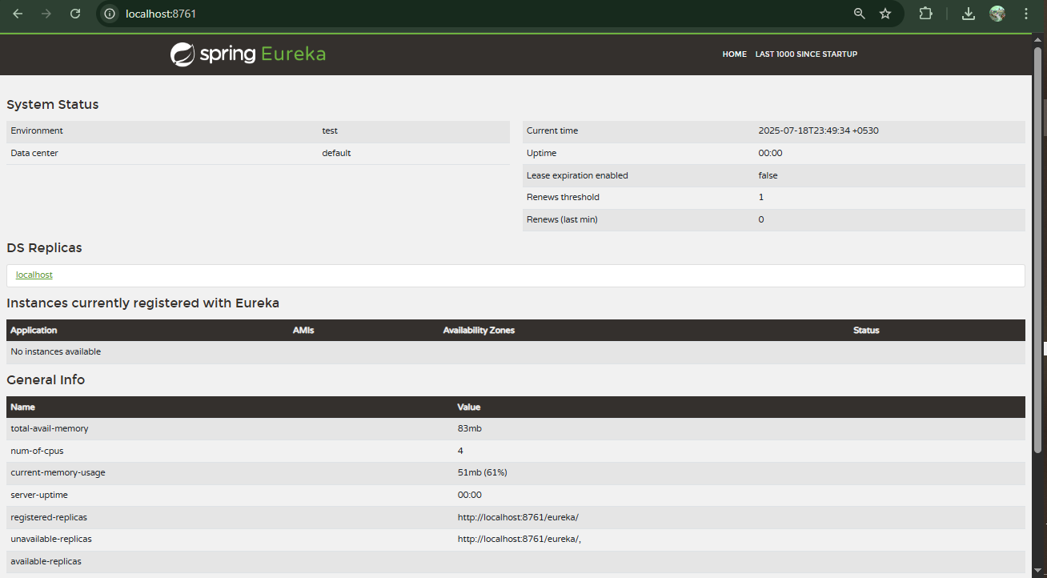

**Register Account REST API to eureka discovery**

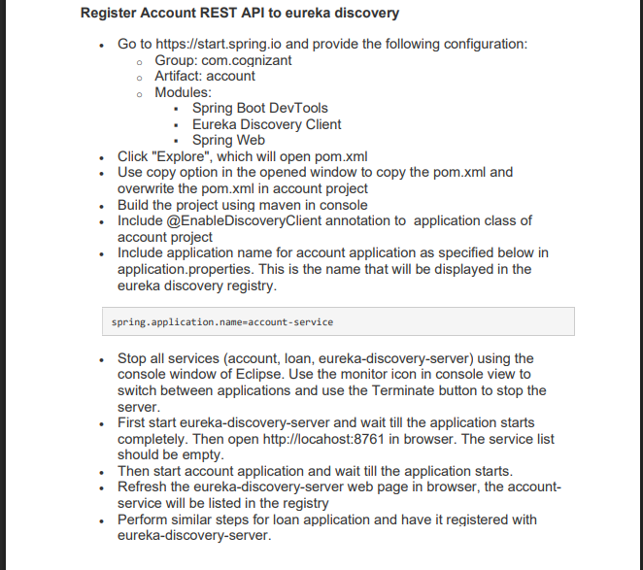

**Solution**

**Account**

**pom.xml**

<?xml version="1.0" encoding="UTF-8"?>

<project xmlns="http://maven.apache.org/POM/4.0.0" xmlns:xsi="http://www.w3.org/2001/XMLSchema-instance"

xsi:schemaLocation="http://maven.apache.org/POM/4.0.0 https://maven.apache.org/xsd/maven-4.0.0.xsd">

<modelVersion>4.0.0</modelVersion>

<parent>

<groupId>org.springframework.boot</groupId>

<artifactId>spring-boot-starter-parent</artifactId>

<version>3.5.3</version>

<relativePath/> <!-- lookup parent from repository -->

</parent>

<groupId>com.cognizant</groupId>

<artifactId>account</artifactId>

<version>0.0.1-SNAPSHOT</version>

<name>account</name>

<description>Demo project for Spring Boot</description>

<url/>

<licenses>

<license/>

</licenses>

<developers>

<developer/>

</developers>

<scm>

<connection/>

<developerConnection/>

<tag/>

<url/>

</scm>

<properties>

<java.version>17</java.version>

<spring-cloud.version>2025.0.0</spring-cloud.version>

</properties>

<dependencies>

<dependency>

<groupId>org.springframework.boot</groupId>

<artifactId>spring-boot-starter-web</artifactId>

</dependency>

<dependency>

<groupId>org.springframework.cloud</groupId>

<artifactId>spring-cloud-starter-netflix-eureka-client</artifactId>

</dependency>

<dependency>

<groupId>org.springframework.boot</groupId>

<artifactId>spring-boot-devtools</artifactId>

<scope>runtime</scope>

<optional>true</optional>

</dependency>

<dependency>

<groupId>org.springframework.boot</groupId>

<artifactId>spring-boot-starter-test</artifactId>

<scope>test</scope>

</dependency>

</dependencies>

<dependencyManagement>

<dependencies>

<dependency>

<groupId>org.springframework.cloud</groupId>

<artifactId>spring-cloud-dependencies</artifactId>

<version>${spring-cloud.version}</version>

<type>pom</type>

<scope>import</scope>

</dependency>

</dependencies>

</dependencyManagement>

<build>

<plugins>

<plugin>

<groupId>org.springframework.boot</groupId>

<artifactId>spring-boot-maven-plugin</artifactId>

</plugin>

</plugins>

</build>

</project>

**AccountApplication.java**

package com.cognizant.account;

import org.springframework.boot.SpringApplication;

import org.springframework.boot.autoconfigure.SpringBootApplication;

import org.springframework.cloud.client.discovery.EnableDiscoveryClient;

@SpringBootApplication

@EnableDiscoveryClient

public class AccountApplication {

public static void main(String[] args) {

SpringApplication.run(AccountApplication.class, args);

}}

**application.properties**

spring.application.name=account-service

**Output**

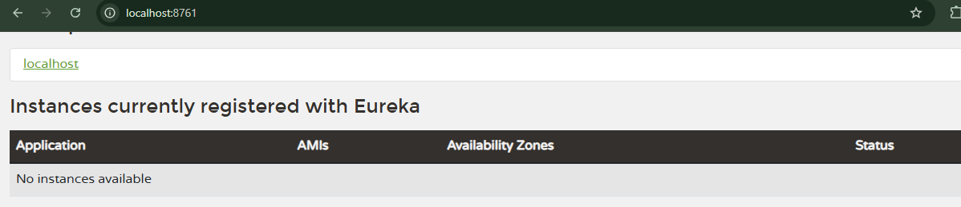

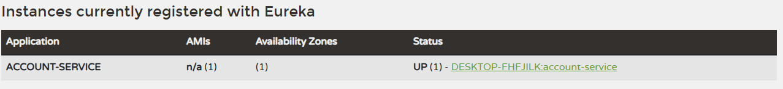

**Loan**

**pom.xml**

<?xml version="1.0" encoding="UTF-8"?>

<project xmlns="http://maven.apache.org/POM/4.0.0" xmlns:xsi="http://www.w3.org/2001/XMLSchema-instance"

xsi:schemaLocation="http://maven.apache.org/POM/4.0.0 https://maven.apache.org/xsd/maven-4.0.0.xsd">

<modelVersion>4.0.0</modelVersion>

<parent>

<groupId>org.springframework.boot</groupId>

<artifactId>spring-boot-starter-parent</artifactId>

<version>3.5.3</version>

<relativePath/> <!-- lookup parent from repository -->

</parent>

<groupId>com.cognizant</groupId>

<artifactId>loan</artifactId>

<version>0.0.1-SNAPSHOT</version>

<name>loan</name>

<description>Demo project for Spring Boot</description>

<url/>

<licenses>

<license/>

</licenses>

<developers>

<developer/>

</developers>

<scm>

<connection/>

<developerConnection/>

<tag/>

<url/>

</scm>

<properties>

<java.version>17</java.version>

<spring-cloud.version>2025.0.0</spring-cloud.version>

</properties>

<dependencies>

<dependency>

<groupId>org.springframework.boot</groupId>

<artifactId>spring-boot-starter-web</artifactId>

</dependency>

<dependency>

<groupId>org.springframework.cloud</groupId>

<artifactId>spring-cloud-starter-netflix-eureka-client</artifactId>

</dependency>

<dependency>

<groupId>org.springframework.boot</groupId>

<artifactId>spring-boot-devtools</artifactId>

<scope>runtime</scope>

<optional>true</optional>

</dependency>

<dependency>

<groupId>org.springframework.boot</groupId>

<artifactId>spring-boot-starter-test</artifactId>

<scope>test</scope>

</dependency>

</dependencies>

<dependencyManagement>

<dependencies>

<dependency>

<groupId>org.springframework.cloud</groupId>

<artifactId>spring-cloud-dependencies</artifactId>

<version>${spring-cloud.version}</version>

<type>pom</type>

<scope>import</scope>

</dependency>

</dependencies>

</dependencyManagement>

<build>

<plugins>

<plugin>

<groupId>org.springframework.boot</groupId>

<artifactId>spring-boot-maven-plugin</artifactId>

</plugin>

</plugins>

</build>

</project>

**application.properties**

server.port=8081

spring.application.name=loan-service

eureka.client.service-url.defaultZone=http://localhost:8761/eureka

**LoanApplication.java**

package com.cognizant.loan;

import org.springframework.boot.SpringApplication;

import org.springframework.boot.autoconfigure.SpringBootApplication;

import org.springframework.cloud.client.discovery.EnableDiscoveryClient;

@SpringBootApplication

@EnableDiscoveryClient

public class LoanApplication {

public static void main(String[] args) {

SpringApplication.run(LoanApplication.class, args);

}

}

**Output**

